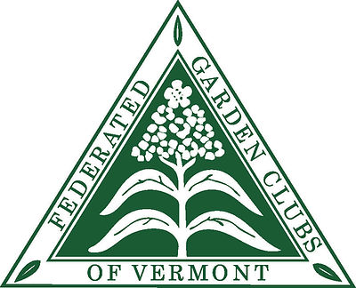 Vermont Leaf
spring 2023

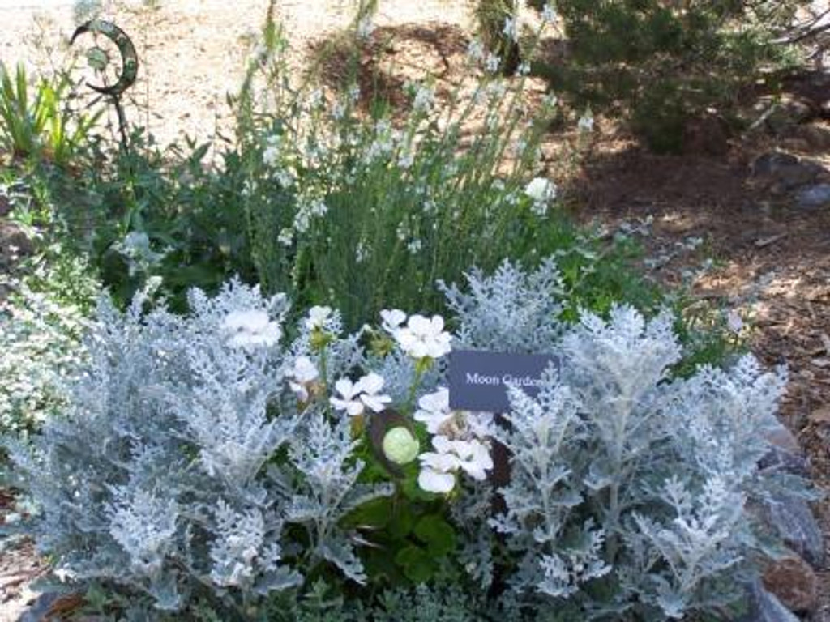

FEDERATED GARDEN CLUBS OF VERMONT, INC.
MEMBER OF NATIONAL GARDEN CLUBS, INC.

President’s Letter

Dear Garden Club Presidents and members,

Spring has sprung in Vermont. I have been home from Florida only a few days but the days have been sunny, beautiful and pleasant. Today it is 60 degrees+ in Shrewsbury and I relished raking leaves out of my perennial flower gardens. It felt glorious to work outside.

Some FGCV activities coming up soon.

May 16|17 2023 Trip to Ottawa, Canada to the Tulip Festival, poster follows.

June 6, 2023 FGCV ANNUAL MEETING.
Philo Ridge Farm
Charlotte, VT
This is 400 acres of commercial farm with many acres of flowers, veggies, and various animals. The food served us for lunch at the meeting will have been raised on the farm. TOURS of the farm are available. Be sure to REGISTER. Find the registration form here in The Leaf.

Summer Tours available for Clubs of the Ganmas and Grandpas Garden in Burlington. Contact Jan Desarno, jandesarno@mail.com.

We hear so much about Native Plants these days I always wonder what plants are native to Vermont. Why do we want to plant Native Plants? Do they benefit our soil, insects, and wild animals?

This will be my last President’s letter of my 2 years of working with a terrific executive board and getting acquainted with many of the club members. The people involved in garden clubs are fantastic - hard working, interesting and have been the most rewarding part of this position. Thanks for the ride… I have enjoyed working with you in many ways. Doris Van Mullen will become the next FGCV President. She is looking forward to the job and is organized, efficient and up to the task. Doris has been working on plans to move FGCV forward with the help of all of you.

I am not going totally away. I will become the FGCV Awards Chair and will be working with many of you in that capacity. We are updating the awards on the website to make it easier to apply for State, Regional and National awards.

See you at annual Meeting!

Best Regards

Jo
Brattleboro Floral Arts & Garden Club

The Brattleboro Garden Club has started the year with an organizational meeting in person, inside! Although our March meeting was postponed due to weather – and then canceled due to our speaker having COVID – we are optimistic that things are now returning to normal.

Our programming this year includes learning about care for hanging and potted plants, garden tours, flower arranging, meditation in the garden, a special learning opportunity when one member opens her garden for fellow members’ suggestions, an annual meeting, wreath making and centerpiece designing. We also voted to resume our fall mum sale. We opted out of a spring perennial sale, concerned about unknowingly sharing jumping worms.

“We are gearing up for a great year,” comments incoming club president Jill Stahl Tyler. “We owe a real debt of gratitude to outgoing president Lynne Kennedy who served for three years. All three of those years she served dealing with the constant uncertainty of COVID. Lynne did an admirable job, listening to all opinions while making club members feel as safe as possible while enjoying a variety of programming, Thank you, Lynne!”

St Albans Garden Club

Hello fellow gardeners, we are the St. Albans Garden Club. We have 25 fine men and women members active in our community.
Some of our yearly club activities include a spring plant sale, planting annuals in our local historic downtown Taylor Park, and our favorite “Plant it Pink” cancer ribbon garden on or local hospital lawn. It blooms every year with over 200 pink tulips and annual pink petunias. It is quite the sight to see.
Some of the monthly events that we have had over the years include environmental education movie nights, hosting Bridget Butler the “Bird Diva” and touring different local greenhouses and nurseries.
Every year we pick a special garden to tour in the summer growing season. Some of our favorites include Shelburne Farms, UVM Gardens and Horticulture Farm, Montreal Botanical Gardens, Cold Hollow Sculpture Park and the Burlington Garden Park.
Our club also enjoys doing Flower Arrangements. We have had many FGCV experts and judges give our club hands on demos and tips for greater success at a flower shows.
Many of our club members organize and put on a flower show at the Franklin County Field Days in August.
Our club is always excited when it’s a Vermont Flower Show Year and we can show off our talents and creativity of our members of all ages.
This year we are pleased to host other garden clubs and the Master Gardeners to Tour our Downtown St. Albans streetscape. We will also tour our beautiful pollinator and rain gardens in historic Taylor Park.
We are wishing you a wonderful growing season full of new discoveries and happiness.
Kelly Wakefield

TULIPS

Tulips are a common Spring flower but how much do you really know about them. They are Descendents from wildflowers in Central Asia. 3,000 years ago they grew in what is now Turkey. Tulips are Turkey’s national flower. In the 500s tulips made their way to Europe and in 1630 were grown commercially.

Holland is now recognized as the largest producer of tulip bulbs, about 3 billion bulbs a year.

There are 3500 named tulip varieties that come in a wide selection of colors and flower shapes. They have early, mid and late spring bloomers. Tulips prefer full to partial sun. After flowering be sure to let the foliage die down to allow the bulbs to restore nutrients. They are a favorite snack of deer but there are spays that keep the deer at bay.

Enjoy the spring beauties as you travel around Vermont and beyond. At the Tulip Festival we are looking forward to seeing many colors and sizes of those wonderful flowers we have waited for all winter.

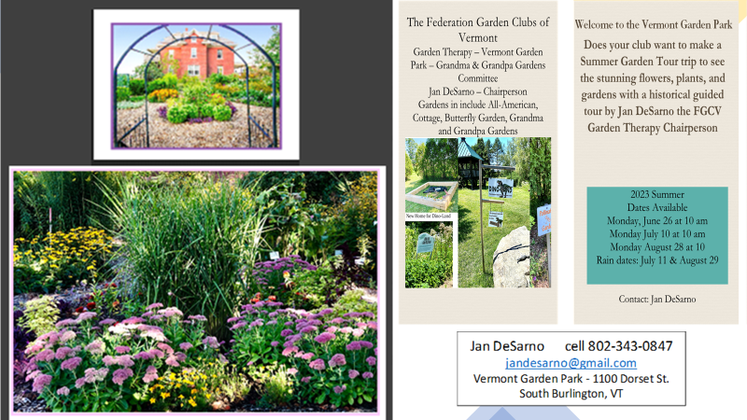

Jan DeSarno is the Garden Therapy new Chairperson for 2023-2025 and will offer garden tours of the Vermont Garden Park
at the Wheeler House in South Burlington,
1100 Dorset Street, South Burlington, Vermont.

Thank you.
Best, Doris

REGISTRATION OPEN ONLINE

https://www.vermontfgcv.com

2023 Federated Garden Clubs of Vermont
Annual Meeting

Join us on Tuesday, June 6, 2023
Time: 10:00 AM

Philo Ridge Farm
2766 Mt. Philo Road
Charlotte, Vermont 05445

Guest Speaker: Gail Kirby

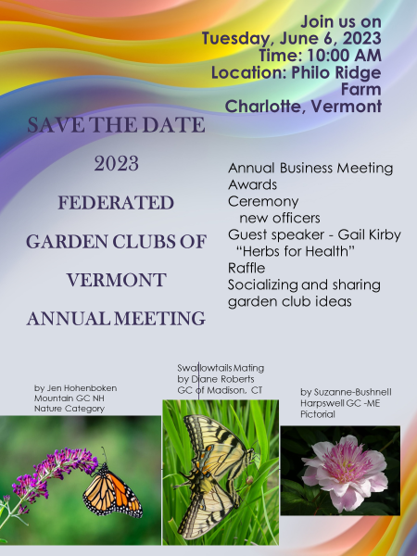

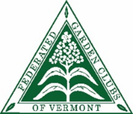

Federated Garden Clubs of Vermont Annual Meeting
Registration Form
Tuesday, June 6, 2023
Philo Ridge Farm, Charlotte, Vermont
Name________________________________________________
Address___________________________________________________
Phone #_____________________Email____________________________
Club ________________________________________________________
The North District invites you to the FGCV 2023 Annual Meeting on Tuesday, June 6, 2023. It will be held at the Philo Ridge Farms, 2766 Mt. Philo Road, Charlotte, Vermont 05445
Please check all that apply
Local –
_____ CLUB MEMBER
_____ GUEST
_____ CLUB PRESIDENT (current or alternate)
_____ CLUB FORMER PRESIDENT
State – Federated Garden Clubs of Vermont
_____ FGCV LIFE MEMBER
_____ FGCV OFFICER (current)
Pres/Co ____VP ____ 2VP ____ Sec. ____ Treas. ____
District Directors: North ___ Central ___ South ____
_____ FGCV COMMITTEE CHAIRPERSON (current)
_____ FGCV FORMER PRESIDENT (or Co)
Regional – New England Regional Garden Clubs
_____ NEW ENGLAND REGIONAL GARDEN CLUBS (NEGC) OFFICER
(Current Director/board member)
_____ NEW ENGLAND REGIONAL GARDEN CLUBS FORMER DIRECTOR
National Garden Club
_____ NATIONAL GARDEN CLUB (NGC) BOARD MEMBER (current)
_____ NATONAL GARDEN CLUB LIFE MEMBER

Registration:
Registration fee is $40 (includes registration fee, business meeting, guest speaker and lunch). Additional fee for nonmembers: $10
Menu selection and submission of registration form information on page 2.
Menu - Check Your Choice – burgers and sandwich (with fries or greens)
___ Griddled beef burger - cheddar, pickled onions, dijonaise, farm greens,brioche bun
___ fries or ___ greens
___ Philo Veggie Burger - goat cheese, pickled veggies, aioli, brioche bun
___ fries or ___ greens
___ Grilled Chicken or Turkey Sandwich (determined by flock size) - Smoked queso fresco, sauerkraut, paprika mayonnaise, farm greens, house focaccia
___ fries or ___ greens

Snacks for table: Vegetable crudité - In season vegetables, Green goddess dressing Vermont cheese Apple butter, seeded crackers House charcuterie Pickles, mustard & grilled bread

Menu: subject to change – use of current foods growing in gardens and farm

Philo Ridge Farm is a beautiful 400-acre productive, diversified farm at the forefront of innovation and conversation around food grown on the land. Fifty acres are used as certified organic vegetable, flower, herb, and fruit gardens. Focus is on grass-fed & pasture raised lived livestock growing cattle, pigs, chickens, eggs, and sheep. philoridgefarm.com

REGISTRATION INFORMATION:
Make check payable to: Federated Garden Clubs of Vermont
Registration deadline: May 29, 2023
Electronic registration and email registration – send check to: Doris Van Mullen
Mail registration – send registration form and check to Doris Van Mullen
Doris Van Mullen
94 Primrose Lane, Williston, Vermont 05495
Cell: 615-390-9965 djvanmullen@gmail.com

Tentative meeting schedule – subject to change
9:30 - 10:00 am Registration - Meet and Greet
10:00 am Business Meeting – Jo Fretz – Co-President
Installation of incoming officers - (2023-2025)
11:30 am Lunch and socializing
12:30 pm Guest Speaker – Gail Kirby – “Herbs for Health”
1:30 pm Auction results
Garden tours available: approximately 45 minutes
____ yes – Ridge and Production Gardens - appreciate seeing the aesthetic beauty of the ridge garden, and the "behind the scenes" utility of what it takes to produce the amount of fruit, vegetables, and flowers to sustain the farm, in the production gardens.

Silent Auction: Each club is asked to bring an auction item(s) for our fundraising raffle. On arrival leave item at the registration table. Take home a special treat.

Attention: Club President/representative – Bring club yearbooks & brochures to share and network. There will be an available table on which to place your materials

Burlington Garden Club Newsletter 2023

The Burlington Garden Club usually celebrates the new year with a luncheon and social gathering. This year, with COVID still surging through the community, we pivoted. Instead of board members providing food, we asked club members to bring their own lunch. To make the meeting more interactive we enjoyed a Yankee Swap. Club member, Deborah Flanders shared her unique and impressive Vermont family history, and sang several beautiful songs.

The January meeting prepared us for Bouquets for Birchwood, a now yearly garden therapy project. Members made and delivered 92 small floral bouquets to Birchwood Rehabilitation and Care Home residents. Spearheaded by Karen Villanti and Doris Van Mullen, the bouquets brought sunshine on a frigid, grey day.

Valentine’s Day also signals another BGC service project. Coordinated by Jan DeSarno, members made 300 individually-wrapped, heart-shaped sugar cookies for Meals on Wheels recipients as well as the South Burlington Food Bank.

Co-presidents Barbara Gaida and Linda Lane hosted a new member brunch. Several board members visited with the new members to discover their interests, as well as their availability. The connections we established at the brunch made it easier to fill open club positions.

In March, BGC members volunteered to bring food for the judges and to clerk at the National Small Standard Flower Show in Essex Junction. Assisting the judges by taking notes introduces clerks to the process of judging at a flower show. Barbara Gaida was awarded an Honorable Mention for her tubular arrangement, Nancy Bell received First place in Horticulture, and an Honorable Mention for her cascade. Doris Van Mullen received Second place for her educational poster.

BGC is planning a fabulous fund-raising trip to the Montreal Botanical Gardens on June 30th. Hosted by national gardening expert Charlie Nardozzi. and guided by Deb Flanders of Goodspeed and Bach, we will board an air-conditioned motor coach for a full day excursion to the Montreal Botanical Gardens. Included in the price is transportation, entrance fee, lunch and gratuities. $169 per person. Deadline: May SPRING

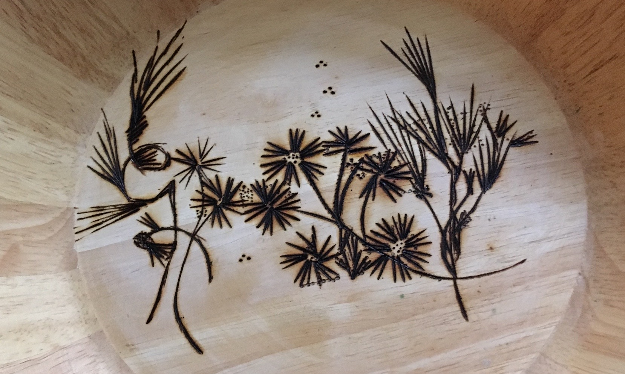
Pyrography flowers

National Garden Week

National Garden Week: June 4-10 2023

Celebrate National Garden Week in Your Community!

Join NGC clubs across the country and celebrate National Garden Week, June 4-10, 2023. This week is an opportunity to encourage pride in your community, interest new members, an Ideas to Consider:
- Plan an educational program and/or workshop at your local library, public garden or garden center.
- Sponsor a hands-on "How Do You Select Flowers/Shrubs for Your Garden" workshop at an area nursery.
- Plan a garden tour. This is a great time to share your knowledge of growing while sharing ideas.
- Beautify a manageable blighted area or enhance an existing garden. This would be a good opportunity to work with other groups.
- Plan an activity with a youth group or school students.
- Place a plant or flower arrangement at public facilities, along with one of the beautiful National Garden Week posters.

There are two versions of the National Garden Week poster. One is a fillable PDF file so that the name of a local garden club can be added before printing.
DOWNLOADS
National Garden Week Proclamation
National Garden Week Poster
National Garden Week Poster (Fillable)

Federated Garden Clubs of Vermont
Spotlight Small Standard Flower Show Exhibits at the VT Flower Show
The floral landscapes were stunning at the “Spring Comes to the 100-Acre Wood” – “Out of Hibernation: The Magic of Pooh” 2023 Vermont Flower Show. The National Garden Club Small Standard Flower Show had enchanting exhibits of Design, Horticulture, Educational, Youth, and Botanical Arts sponsored by The Federated Garden Club of Vermont Judges’ Council with assistance and support from Green Works, the Vermont Nursery and Landscape Association.
The indoor flower show, from Friday, March 3 through Sunday, March 5 inspired new ideas for outdoor spaces and a remedy for spring fever. The exhibitors were enthusiastic garden club members throughout Vermont including: Arlington Garden Club, The Burlington Garden Club, Randolph Garden Club, Rutland Garden Club, and St. Albans Garden Club. Each exhibit brought the magic of spring to life for those who attended.
“Inside the Honey Pot,” the Judges’ Invitational Class featured creative, colorful, coordinated designs focused on getting ready for spring. The immersive floral spectacular delighted the senses using balance, contrast, dominance, proportion, scale, and rhythm.
“Roo in the Pouch” displayed the principles of Parallel Design. Beautiful flowers and other plant material were used to create distinct, visually pleasing parallel patterns.
“Christopher Robin Meets Pooh” explored Tubular Designs of fresh plant material and magical combinations of flowers. Tubular floral designs incorporated dominant cylindrical forms throughout.

“Eeyore’s Song” were entries of Cascade Designs. Cascade Design emphasizes the downward rhythmic movement of flowers and other plant material with a minimum of components extending upward.

The Horticulture sections and classes of “Let it Grow” included specimens of live branches, foliage, plants, flowering plants, cacti, and succulents. The Evergreen branches and foliage, and Deciduous and Rhododendron branches displayed provided a vivid reminder of live trees and shrubs in late Winter.
The variety of flowering, foliage, and “Prickly and Puffy” Cacti and Succulent plants grown in containers provided hope and inspiration to all houseplant enthusiasts who viewed them.

“Growing Smarter”, the theme for the Educational Exhibits were interactive and engaging immersive posters and included: Green Trees of the Green Mountain State, The Symbolic Meaning of Flowers and How to be Involved in the Local Garden Clubs in Vermont.

The delightful immersive educational posters made by Elementary School children K- 5 included: “Smarter Than You Think” - Hens and Chickens and Lady Finger Cactus.

“Up, Down, Touch the Ground” the Youth poster and plant exhibits were the class work of Elementary School students. The school children showcased remarkable colorful, heartwarming scenes of growing and sustaining succulents and cactus.

“A Nice Place for Picnics” Botanical Arts: Horticulture scenes were miniature, decorative Fairy Gardens consisting of tiny accessories and small plants made by Montgomery VT Elementary School students. The little gardens sparked imagination and brought an amazing, enchanted world of “fairies” to life.

“Hanging Out with Pooh” Botanical Arts Artistic Crafts were inspirational designs using dried and or fresh plant material to create Honey Pots for Pooh and highlighted the amazing creative talents of the artist adults who made them.

Kathy Perkins, Flower Show General Chairman, stated, “The whimsical Magic of Pooh themes were showcased with live flowers, and plants throughout the show. Featured landscapes inspired the feeling of hope for a brighter Spring ahead. Flower Shows give back to the community. They make a creative impact when local garden clubs offer and participate in creating a floral inspired garden show in communities throughout Vermont”.

>>>>>>>>>>>>>>>>>>>>>>>>>>>>>>>>>>>>>>>>>>>>>>>>>>>>>>>>>>>>>>>>>>>>>>>>>>>>>>>>>>>>>>>>>>>

Interesting Information:

FGCV LIFE MEMBERSHIP
I recently had someone want to know the process for becoming an FGCV Life Member. It was exciting to investigate the procedure and relay it to the club president. It made me want to share the procedure with all our other members.
An FGCV Life Membership can be given to honor any club members. The one-time $50.00 fee is submitted to the President or Lifetime Membership Chair, who submits a life membership certificate to the member and a pin. The money contributed by the club supports the scholarship fund. The person’s name is added to the Life Membership list and kept in the Recording Secretary minutes of the Annual Meeting of the year presented.
You can also become a life member of the National Garden Club and the procedure is on their website.

FGCV Scholarship Awarded
The Executive Board is excited to be able to announce we have awarded a FGCV Scholarship of $1000.00 to a young woman who is beginning a masters degree program in Botany at UVM in the Fall, 2023. Her name is Catherine Wassel. Her undergraduate work was in environmental sciences at UVM. Catherine’s hard work earned excellent grades as well as terrific recommendations. She has had several work experiences in that field and is excited to pursue advanced education. Catherine will be presented her scholarship at the Annual Meeting in June and she will tell us a little more about her future educational plan.
Catherine has also applied for a National Garden Club scholarship of $4000.00 and is waiting for them to make decisions about their NGC awards.
MOON GARDENS
an example is shown on the front cover
Moon Garden - what is it? Is it something we can do in Vermont? Absolutely!!
A Moon Garden is a garden that kind of magically glows after dark by light of the moon or other artificial light that is nearby. You plant white or light-colored flowers. Some flowers that open up at night but mostly just regular white flowers. They can be tall or short or in between. For maximum impact you should plant a group of the same flower (3, 5, 7 like we encourage in regular gardens) together so they will not get lost in among the other flowers and they will pick up that glow more easily. It is important to vary the height and type of the white flowers to create a wave through the garden.
Where do you put that Moon Garden? It is important to choose a spot that you can easily view the garden in the evening. Possibly close to a patio or deck, or a border along a walkway. It can be any size that fits your area or it could be just part of an already established garden. Just be sure you can see it from where you sit or walk bit so the moon can cause that glow.
Some choices of flowers to consider might be moonflower, shasta daisy, yarrow, foxglove, alyssum, salvia or cleome. Spring bloomers might be white daffodils, lily of the valley, or azaleas. If you want to extend the season in the Moon Garden you might add mums or autumn joy clematis. The kinds of flowers are endless but need to be white or very light. Foliage plants to compliment the white can be plants with silvery or variegated leaves. The Moon picks up those plants also. Suggestions of appropriate plants might be lambium, japanese painted fern, brunnera, lambs ears or dusty miller. Intersperse the foliage among the plants as appropriate.
If you have room, you could add a backdrop of shrubs that bloom white flowers. White hydrangea, large or miniature would pick that glow you want. Even trees such as white birch or silver poplar would add lightness.
Other ways to enhance that lightness you want is by adding some white pebbles or rocks, light colored water fountain or some garden art. If you want to emphasize a particular plant in the moon garden and make the glow more predominant, you can add a small solar light or two.
Some of the silver, white or variegated plants add an extra bonus by being fragrant at night. That is a draw for night pollinators as well as emit a pleasant aroma.
Big space or small space or even just a portion of a garden, something new to think about this spring. Give Moon Gardens a try and have fun experimenting.
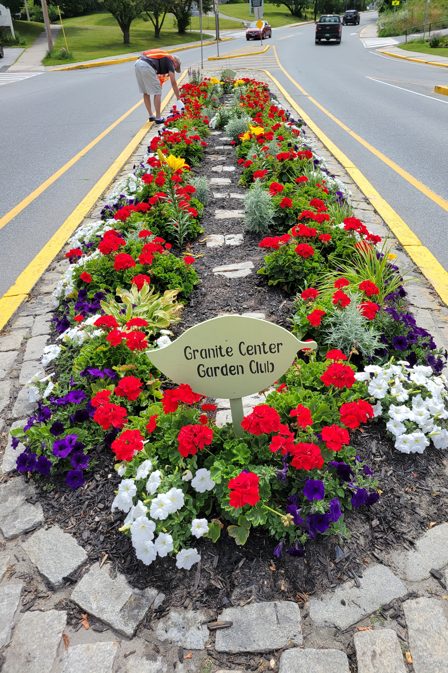
Granite Center Garden Club
The Granite Center Garden Club maintains several city flower beds.
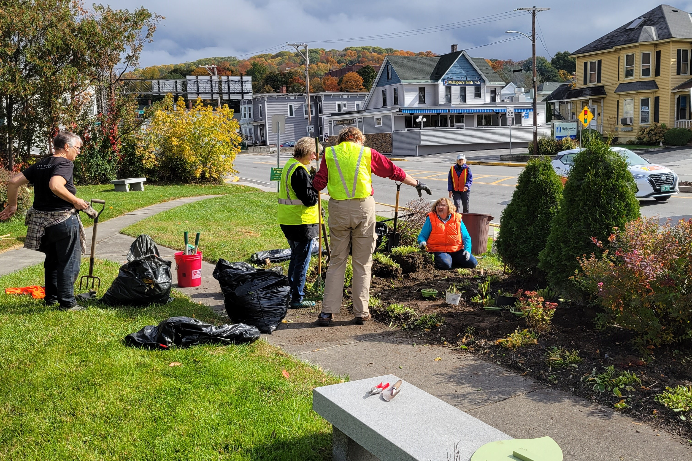
This past season we planted about three hundred red geraniums in our beds. They seemed to flourish and we received many compliments from folks passing by. At the end of the season, the Garden Club felt it would be nice to extend the life of these red beauties. We decided to dig them up, trim them, repot them, and give them away. We took them to the local Farmer’s Market and gave them away to anyone who wanted one or several. The project was a huge success. Many folks were very excited to overwinter the geraniums and were looking forward to seeing them come back to life next spring. Our customers were sharing geranium ideas on how to best care for them through the winter. It was rewarding to see everyone engaged in geraniums.
Our October meeting was held outdoors as a working meeting. Members met at some of the larger city garden beds and worked hard at putting the beds to rest for the season. Many plants needed to be thinned out and divided. These plants were transplanted to pots for safe keeping and will be sold at our annual plant sale in May.

Also, the GCGC is participating in Barre’s “Art Splash 2023” Our car appropriately named “Garden Coupe” is completed and ready for display on Main Street in Barre this summer.
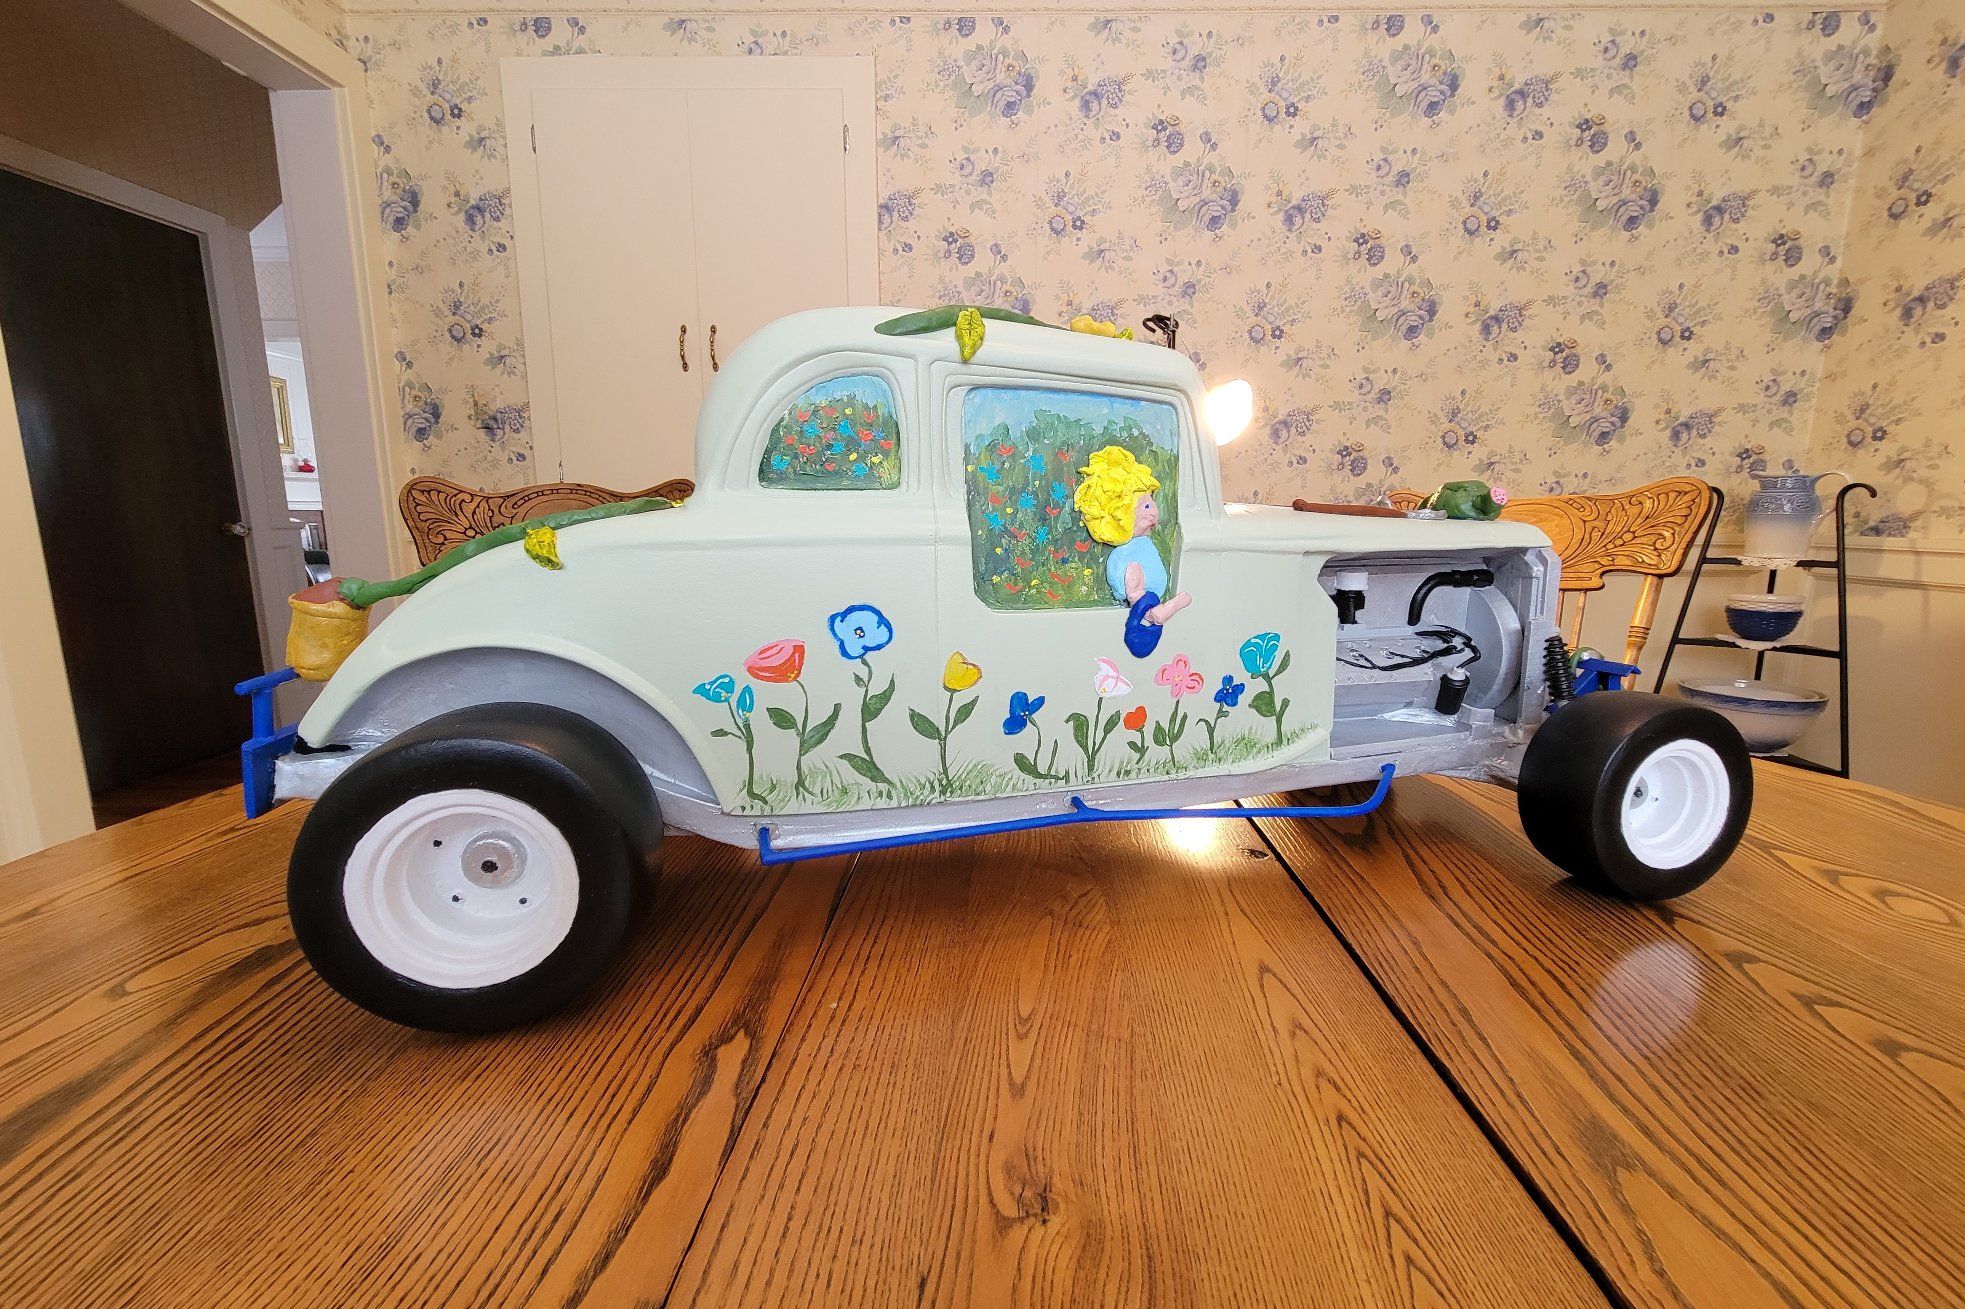
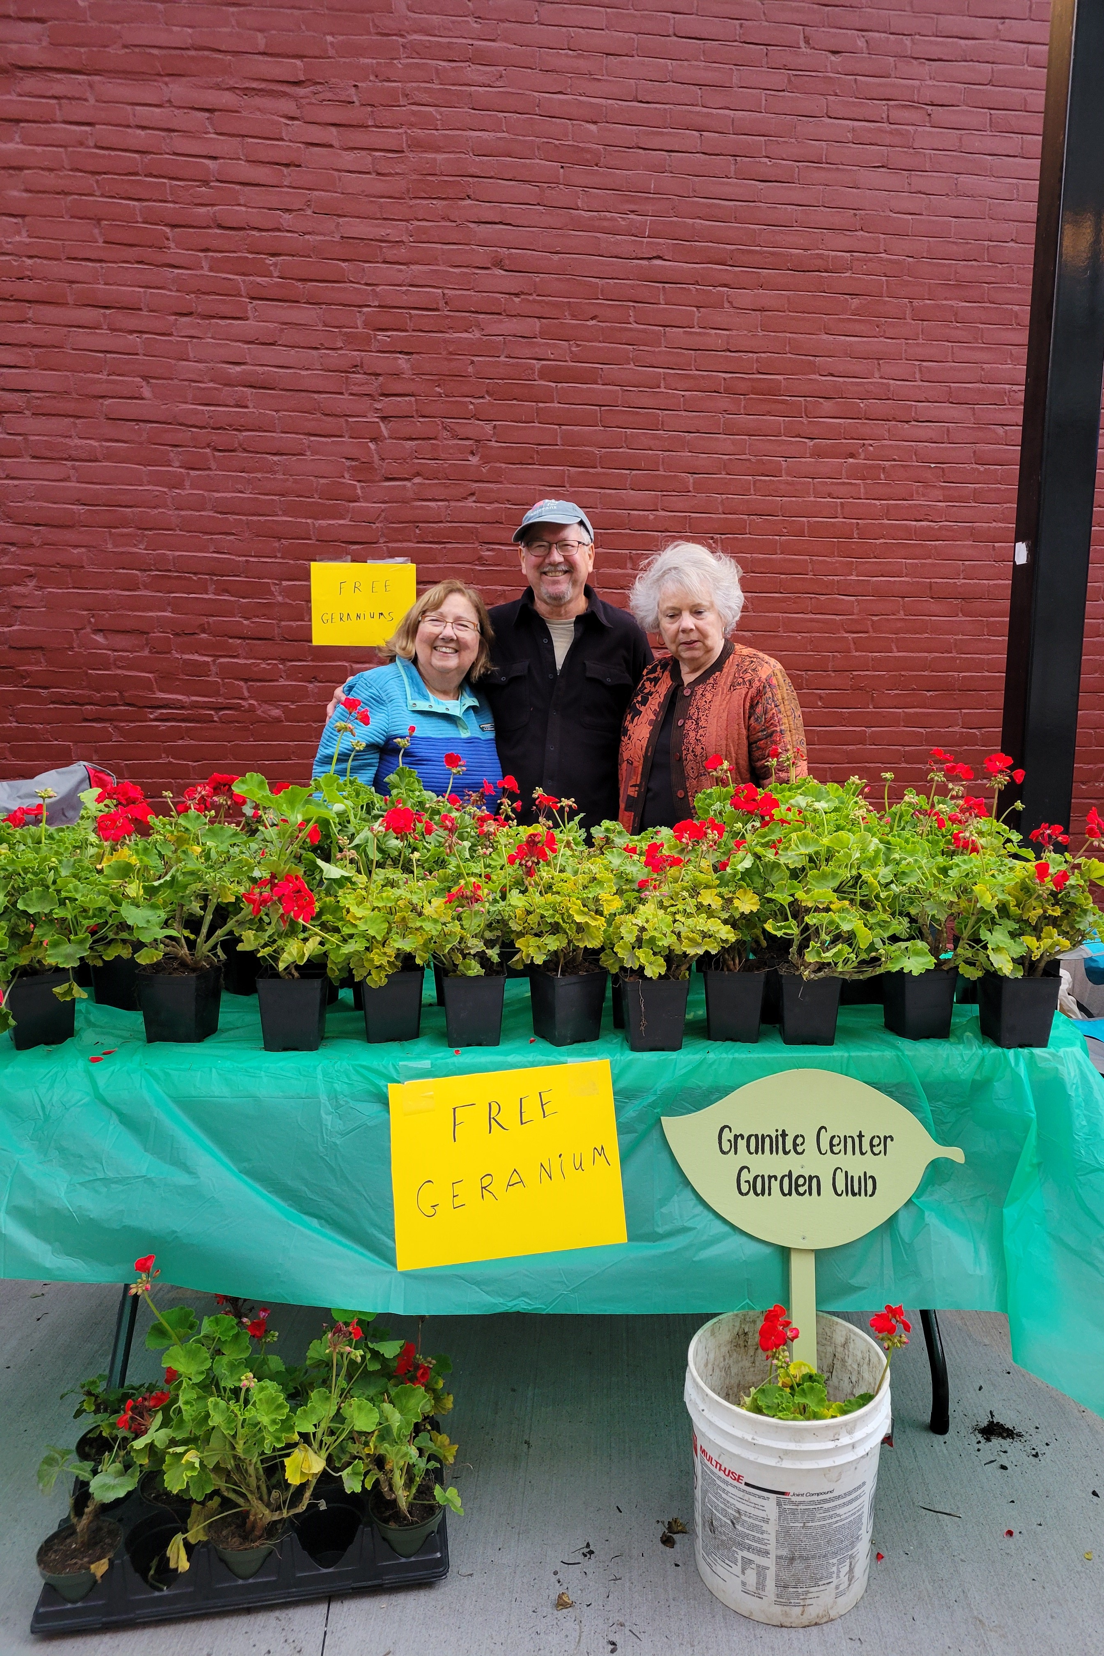

Springfield Garden Club
Springfield Club Hosts Annual Christmas Fundraiser
The Garden Club of Springfield has been hosting an annual "Festival of Trees" fundraiser for twenty-nine years. There is one event...no bake sales or plant sales…just one successful fundraising gala.

Overview
Preparation begins in early Fall, as the charitable event is held on the Friday before Thanksgiving, each year. Guests look forward to the casual, but dressy affair each year. The Club is fortunate to have a venue in town that is ideal. The function is held at "The Great Hall", 100 River Street, which is a community space underwritten by the Springfield Regional Development Corporation. The location features plenty of parking, terrific lighting and plenty of room for members and guests to move about easily from area to area. The club has tried different venues over the years, as attendance continues to grow, the club feels it has outgrown much of the space the local inns could provide. The current location is in a renovated old mill building, close to the center of town. It is a huge airy hall that was once an art gallery. The space houses an adjacent pharmacy and is connected to doctors’ offices so that the public comes and goes all day and the community is able to view the trimmings from mid-November through the first week of January. The Great Hall with Christmas decorations, can be rented for private holiday parties as well.
Nuts and Bolts
-Tickets are sold for the two-hour charity event that begins at 6pm with wine, beer or cider and delicious catered hors d'oeuvres, live music, silent auction, raffle baskets and beautiful wreaths and floral creations for sale. Music is provided by a local jazz band and there is room for dancing, as some guests choose.
-The invitation, by one of our local artists, is designed around a changing theme each year. Past attendees on the list receive a mailed invitation, however, the event is open to the public as well and tickets are sold at the door. Publicity begins three weeks before the event and helps to build momentum. Member workshops to create decorations and greenery also begin 3 weeks ahead.
-"The Festival would not be possible without generous support from civic-minded businesses and individuals in the local area," stated, co-chair, Lynn Likus. "Several Garden Club members volunteer to each choose a theme and provide items that are combined into raffle baskets with a value of approx. $100. each. Last year, there were 14 member gift baskets raffled off during the night of the Festival. The Garden Club is also blessed to have local businesses who give larger gifts which are put into the silent auction; these are things like artwork, jewelry, home heating oil, wood pellets, area rugs, gym memberships, golf discounts, ski lift tickets and more."
-There is also a tree decorating contest for local businesses who sign up in advance. This contest has grown each year and 10 trees are in addition to the 24 decorated, garden club trees. Guests receive a ballot upon entry and vote for their favorite community tree. The winning business receives a gift certificate from a local restaurant.
-"The Garden Club realizes how fortunate we are to have corporate sponsors as well, who support the Festival and our mission with outright donations from their businesses," stated Likus. The club was awarded its official 501c3 status in 2015. All donations are tax deductible to the extent allowable by law.

Where Does the Money Go?
What's important to know is that the Garden Club has very little in day to day, administrative & operational costs. These expenses are almost completely covered by annual membership dues from the approximately 65 members it retains. Another interesting fact is that the active members begin Festival preparations in early October and work for weeks planning, organizing, collecting, decorating, and getting things ready, yet each dedicated member also buys their own ticket to attend the Festival AND works the night of.

Please note that this evening is the sole means of fundraising for the Club. Because day to day operational costs throughout the year are covered by membership dues, nearly one hundred percent (100%) of all corporate donations and proceeds from the Festival go back into the local community in the form of scholarships and programs which benefit the public. This includes scholarships, educational programs and civic beautification efforts throughout the community, such as planters, window boxes and several public garden areas.

Member Workshops
The Festival Committee meets in early September to begin preparations. Workshops for members begin in early November and include wreath making, gingerbread house making, some decorations made in advance, and the floral centerpieces made just days before the event.
Decorations in the Great Hall begin a week in advance of the party. Members begin by putting up the six overhead garlands and red bows which hang between the pillars, the length of the Hall. For this, the Club enlists help from Ted, the Great Hall Maintenance Guru, who commandeers his electric lift with help from Garden Club husbands. Next step is to transfer all of the decorations from the Club's storage facility and get the 24 trees up and lighted. This is done with help from several active members and several yet-willing spouses! We then have one official decorating day where many hands make light work, in order to get the rest of the decorations up.

Tickets
2022 tickets were $35 per person. RSVP is requested in advance, however, tickets are always made available at the door.

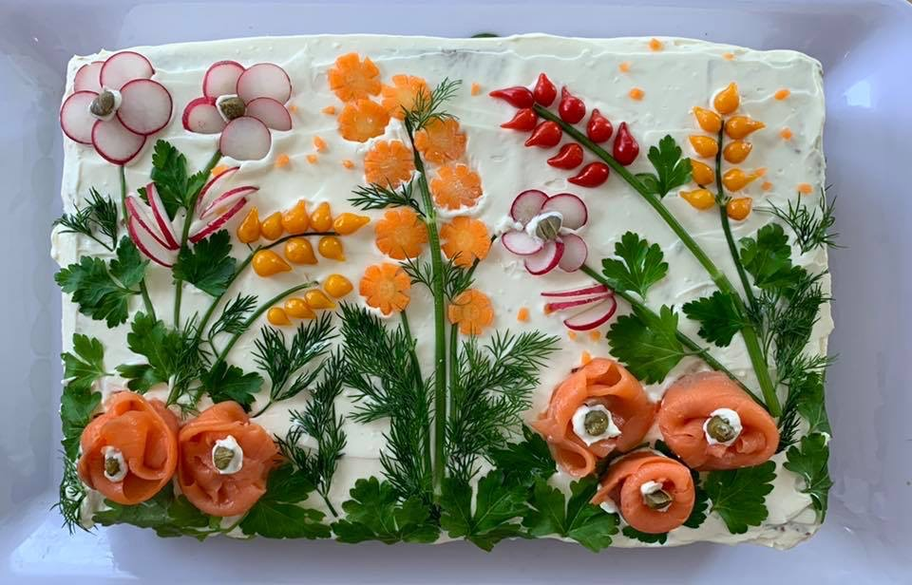

for consumption, vegetables, herbs, smoked salmon party sandwich. ed.

FGCV Judges Council (JC) Report
An informational blurb from Kathy Perkins

The JC is made up of Accredited Flower Show Judges in VT. Each state has a Judges Council. We are the ones that sponsored and put on the Small Standard Flower Show as part of the VT Flower Show, at the Champlain Valley Expo on March 3-4, this year. We are available to any VT Club to share about what JC does, to help you put on a Flower Show, or to give your club a demonstration on aspects of Designs or Horticulture. If you have questions please email
Maryanne Wood, maryannew@caninedimensions.com JC Chairman or
Kathy Perkins, ksheaperk@comcast.net JC Secretary.

>>>>>>>>>>>>>>>>>>>>>>>>>>>>>>>>>>>>>>>>>>>>>>>>>>>>>>>>>>>>>>>>>>>>>>>>>>>>>>>>>>>>>>>>>

Just a little more FYI: Executive Board at present.
Co-Presidents
Jo Fretz *
Margery Salmon
1st Vice President
Doris Van Mullen *
2nd Vice President
Martha Dale
Secretary
Cheryl Pierce
Treasurer
Theresa Burton
Asst. Treasurer
Barb Roitte
Southern District Director
Jean Freebern
Central District Director
Esther Swett
Northern District Director
Mary Scollins
As of June 6, 2023 the officers will change, but only a little. At the Annual Meeting.
* Doris Van Mullen will become the President, Martha Dale will become the 1st Vice President
and 2nd Vice President will become Judy Reed
The other officers will remain the same.
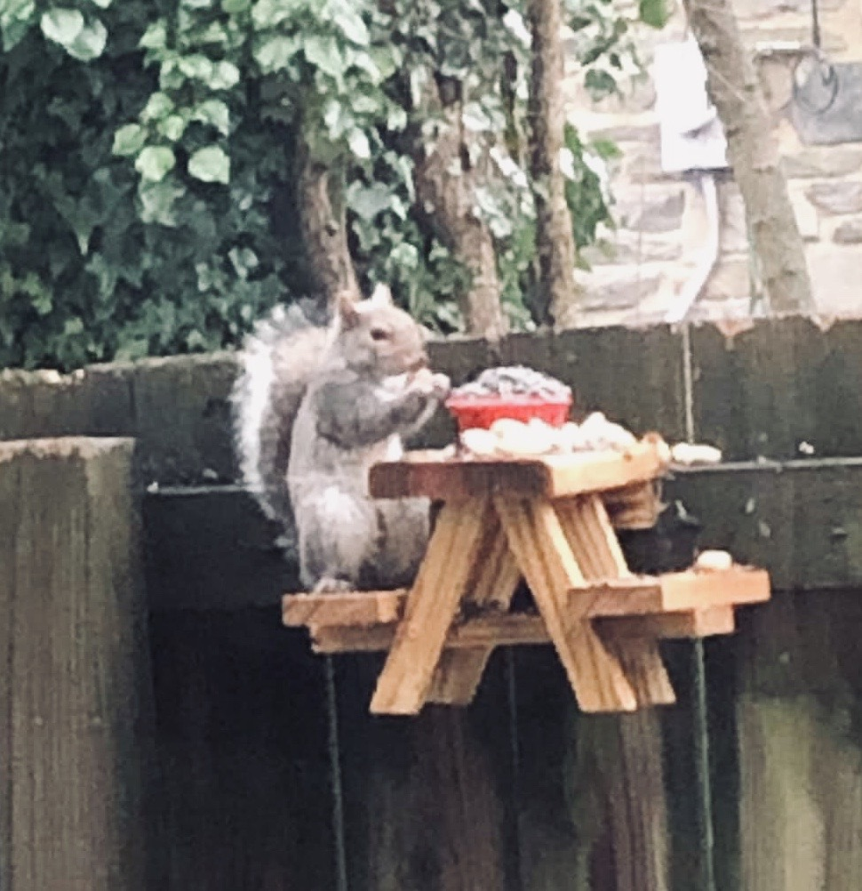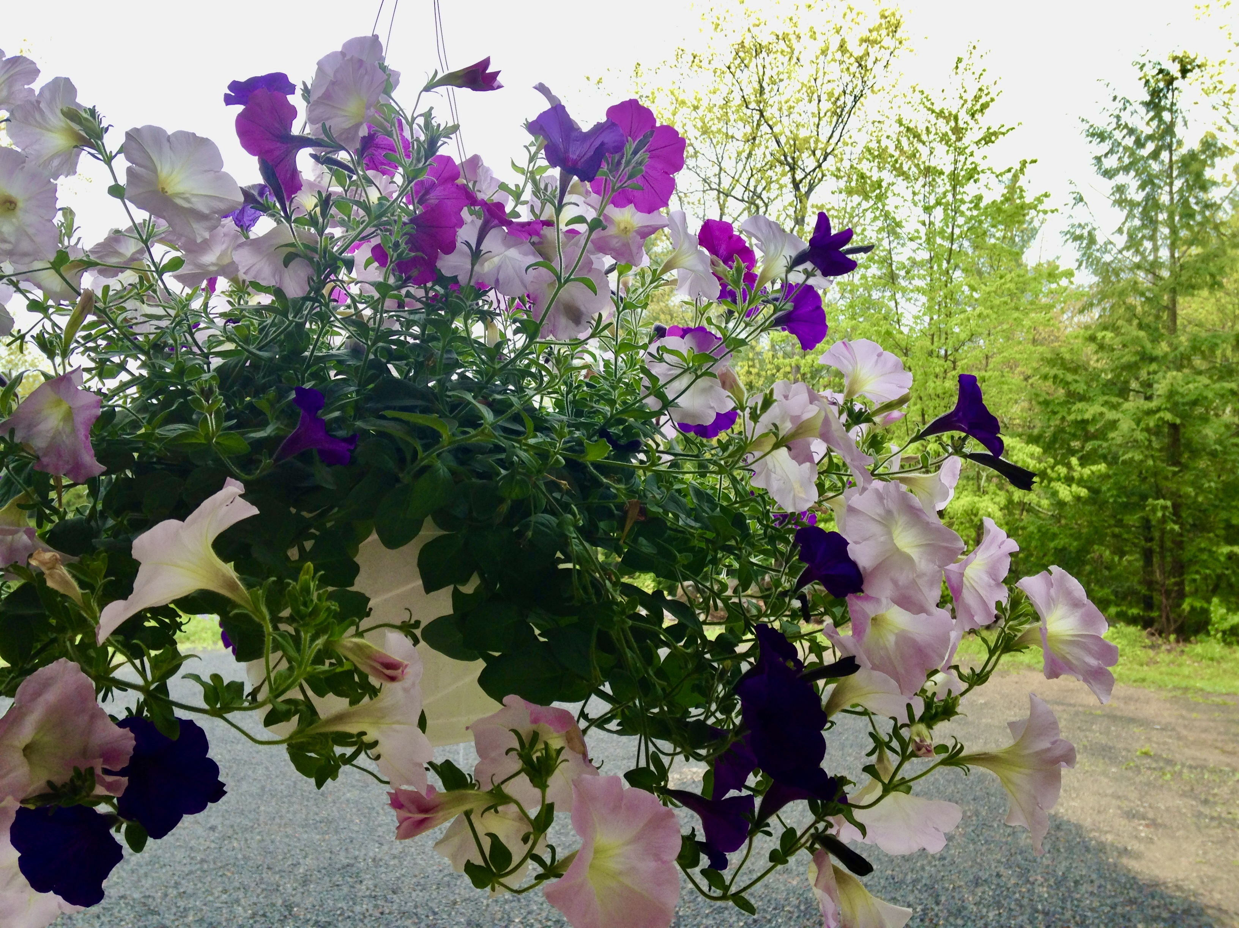
FGVC FALL MEETING

Save the date: Tuesday, October 3

Federated Garden Clubs of Vermont

Survey

We want to explore an adventure for 2024.
As part of our joy being together as gardeners, and to fundraise for our organization, we invite you to help us decide where you would like to go.

Help us select the perfect trip.
